**Michael Rodriguez CMIS 330/6380 Professor Morad, Osama**

**John and Jane’s Bed and Breakfast Software Development Plan**

**Date of Issue:** October 11, 2022

**ID:** 1.000

**Issued By:** Software Development Team Lead

Software Development Plan Approvals.

____________________________________ _______________

Test Manager Date

____________________________________ _______________

Development Project Manager Date

____________________________________ _______________

B&B Co-Owner John Date

____________________________________ _______________

B&B Co-Owner Jane Date

Change history – First Iteration Software Development Plan(SDP) following revisions to supplemental software development documentation.

1. Overview

1.1 Project summary

1.1.1 Purpose Scope and objectives

Purpose - of this Software Development Plan is to document the procedures required to develop a software product capable of handling the needs of the John and Jane’s Bed & Breakfast.

Scope – This Software Development Plan shall cover the desktop application required to aid in the management of the John and Jane Bed & Breakfast.

Objectives – The main objectives of this SDP is to illustrate a project schedule, project risks, Project Task Sets, and Software Development Process.

1.1.2 Assumptions and constraints

This desktop application and database setup allows for scalability, but may be reduced to have the database with each installation and synchronized from peer to peer. The application shall require an internet connection to process email and banking transactions. The database must be in wired/wireless range of each application installation. The owner of the B&B may decide on an external database for scalability or peer to peer to save on infrastructure. This desktop application shall be able to run on any Windows or Mac PC with modern specifications made past 2010.

1.1.3 Project deliverables: Defined through the following Class Diagram of Modules and Submodules.

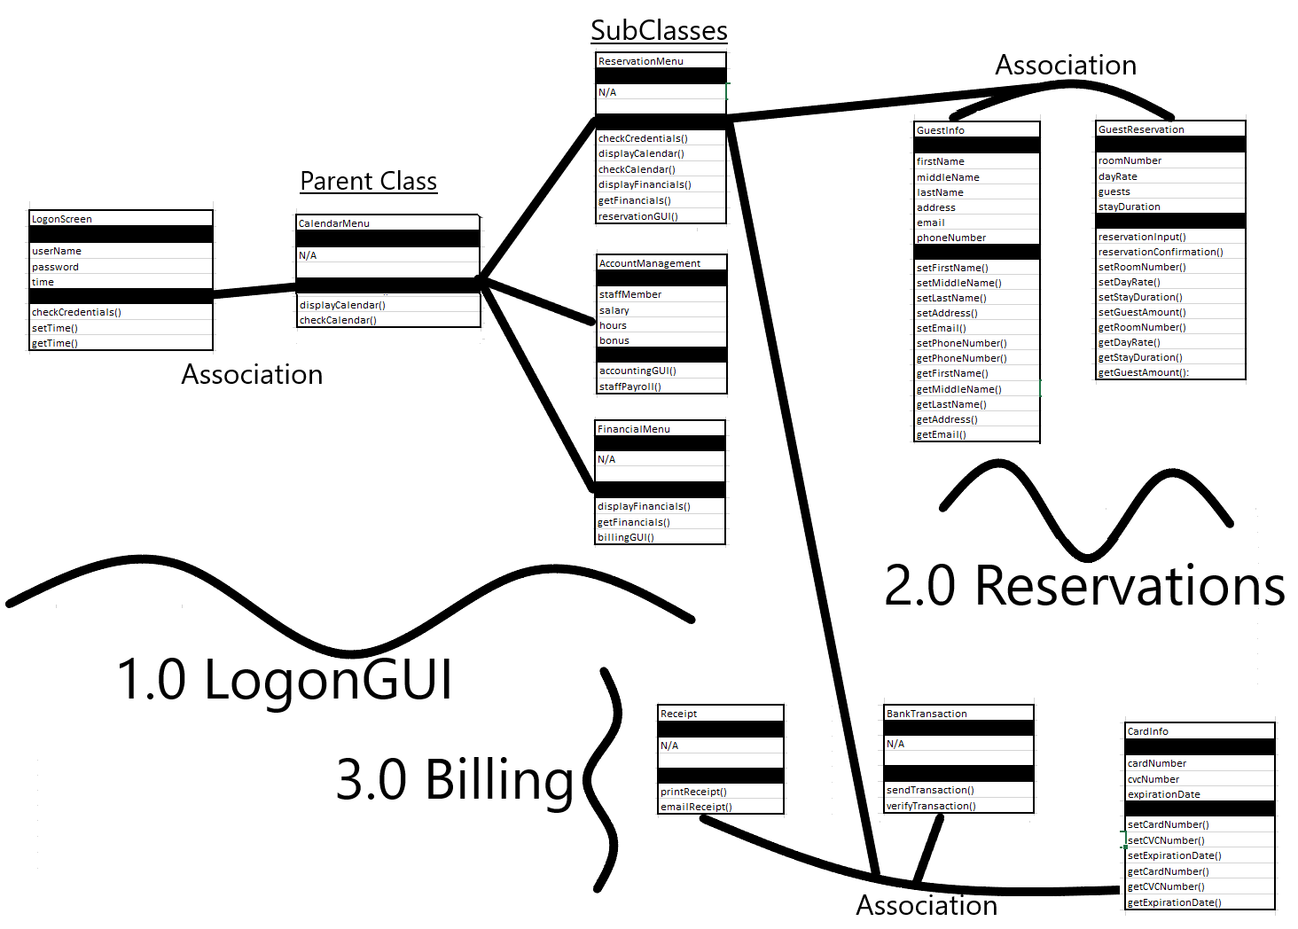

1. References

*Statement of Need*: John and Jane are starting a bed-and-breakfast (B&B) in a small New England town. They will have four bedrooms for guests. They want a system to manage the reservations and to monitor expenses and profits. When a potential customer calls for a reservation, they will check the calendar, and if there is a vacancy, they will enter the customer’s name, address, and phone number, dates, agreed upon price, credit card number, and room numbers. Reservations must be guaranteed by 1 day’s payment. Reservations will be held without guarantee for an agreed upon time. If not guaranteed by that date, the reservation will be dropped.

*IEEE-1058-1998:*Will be used to aid in the creation of this Software Development Plan.

1. Definitions

From here on The Software Development Plan will be referred as SDP and John and Jane’s Bed & Breakfast as B&B. GUI is the Graphical User Interface that the B&B staff will be using within the system. The Card Verification Code will be referred to as “CVC”.

1. Project Organization
   1. External Interfaces
2. Banking Servers
3. Email servers
4. Printer
5. Card Reader

4.2Internal Structure

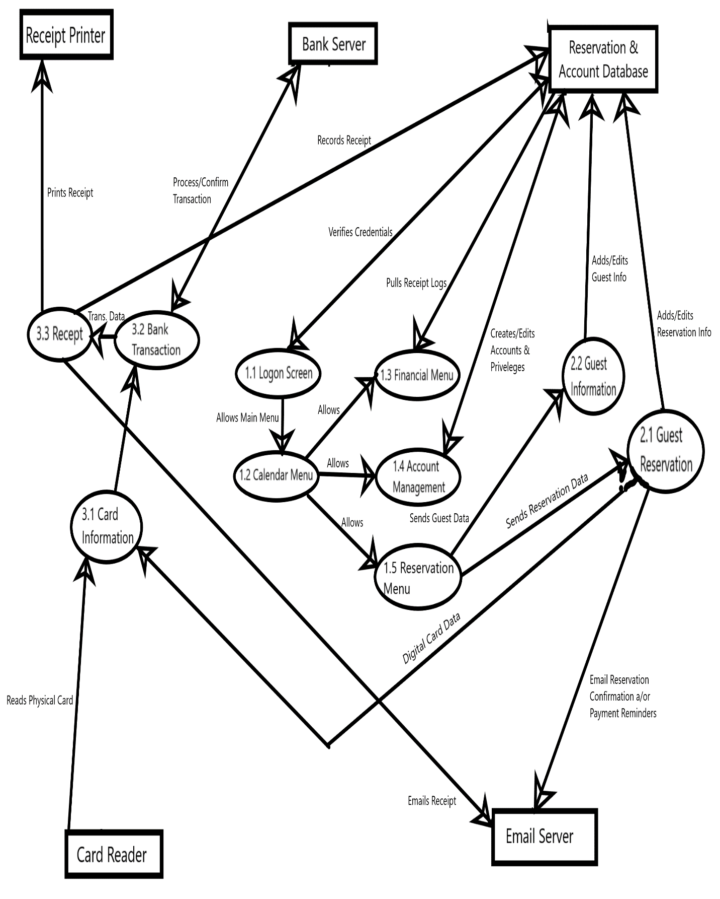

4.3Roles and Responsibilities

Developers: Create the software for the B&B management system in accordance with all of the specifications outlined in the SRS.

Testers: Test all portions of the specifications and deliverables outlined in the SRS, SDD and STS.

Staff: Provide input and feedback to system requirements and functionalities.

Technical Support Staff: Technical Support Staff will not be required, and can be referred to the developers for any technical support necessary.

Data Administrative Staff: The B&B owners will be trained in basic data management for exporting and importing the database and being able to install/change storage locations.

Quality Support Staff: Quality checks shall be conducted by the original staff, but not the original tester. The original statement of need must be referenced along with the SRS.

* 1. Work Plan

5.2.1 Work Activities

Project task set:

1. Identify Customer Need – Half Week
2. System Requirements Review – One Week
3. Budget and plan – Half Week
4. 1.0 GUI Module Development – Two Weeks
5. GUI Module Testing – One Week
6. 2.0 Reservations Module Development – One Week
7. Reservations Module Testing – Half Week
8. 3.0 Billing Module Development – One Week
9. Billing Module Testing – Half Week
10. System Testing – Two Weeks
11. System Implementation – One Week

Note: The Reservation and Billing Modules may be developed in parallel pending available funds.

5.2.2 Schedule Allocation

Gantt Project schedule (Timeline):

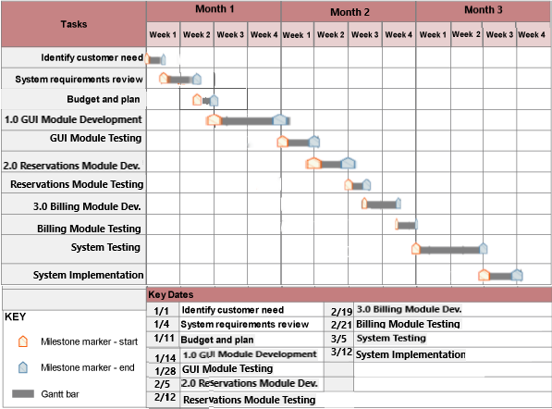

5.2.3 Resource Allocation

Project Duration: Estimate Lines of Code or Function Points. Use these to compute project duration and effort. Project duration should be consistent with the time-line of your Schedule. Knowing project duration and effort permits the computation of staff size, i.e., the number of software engineers required (divide effort by duration to yield staff size). I want to see the computation for effort and staff size in the relevant template Section (section 5.2.3).

5.4 Risk Management Plan

Risk Management Matrix:

|  |  |  |  |
| --- | --- | --- | --- |
| Risk | Probability(%) | Estimated Cost($) | Weighted Impact |
| System Progress Loss | 10% | $1,800 | $180 |
| Internet Failure | 30% | $1,200 | $360 |
| Test Database Loss | 50% | $360 | $180 |
|  |  |  |  |

In case of internet failure preventing testing of the Billing or Reservation Modules, Testing will refocus on other modules or sub modules. A test email server and banking server shall be set up when no other modules may be tested.

1. Technical Process Plans

6.1 Process Model

Software development process: This project implements a hybrid of Sequential and Spiral methodologies where the main modules are to be developed in numerical order. Each module would then follow Boehm’s Spiral Module going through the phases of objectives, development, and testing.

* 1. Methods, tools, and techniques

Software Configuration Management: Includes Software quality assurance and software

configuration management (SCM) procedures.